What counts as a good justification for a claim?

Word count: 931

Alexander Magnus

## Object 1: The Guardian Article at my school about Ukraine.



This is an article from the Guardian Weekly Magazine about the war in Ukraine that I found at the library in my school. The guardian is a well-respected British paper that was founded in 1829. The existence of the paper for almost 200 years justifies that the paper must be useful to have survived so long.

The article talks about how people in Ukraine are preparing for the inevitable invasion. The article is written by an author who to our knowledge is minimizing their biases when formulating the article.

The author has attempted to be neutral and showed various perspectives for the reader to understand the claim he is presenting. They achieve this by presenting a collection of beliefs and experiences from interviews with people affected. The author does not present their opinion on the matter, but only collects information from others. However, because this article is a secondary source there is a lot of information we could be missing. The author could have cherry-picked interviews to better fit the claim he is trying to portray thus giving a stronger position. The author is also limited by the type of media, journals are intended to give you a large quantity of information in a short period of time by writing multiple dense articles on topics that interest the reader. This requires the justifications to be shortened and simplified.

## Object 2: Scientific Research paper on protein supplementation and building muscle mass.

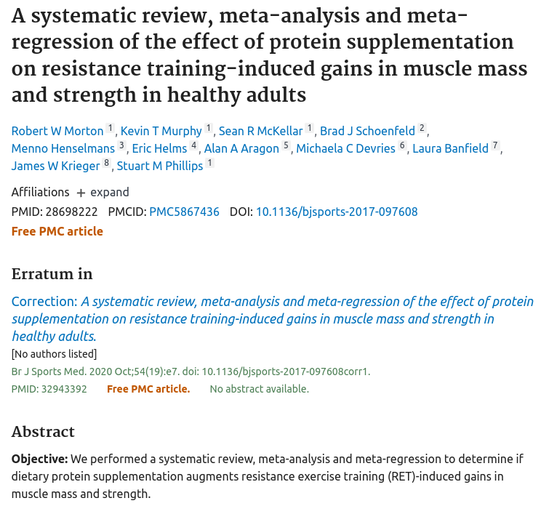

This is a research paper conducted by a sports medicine journal. I read this study because I am interested in fitness, bodybuilding and physical health. I like to watch youtube videos on the topic of fitness to educate myself and obtain the best results. The videos that I watch place references to the studies they used to justify their claims, and I read this one because I was interested in understanding the conclusions.

When I am researching my fitness journey I base the majority of my information on studies as I find them more justifiable than anecdotal evidence. Anecdotal evidence is very popular in fitness, but every human body is different and not everyone will respond the same in identical conditions. In anecdotal evidence, it is hard to tell if a method is superior as there is no control group of how a different method would work.

This study follows the scientific method and conducts an empirically measurable experiment. First, the researchers analyze results from past experiments on the same topic. They plan a method that they will follow to conduct the study and evaluate the limitations and possible systematic errors in their technique. They analyze, extract and explain their understanding of the data that they collected. Lastly, the paper is peer-reviewed to minimize possible biases or errors.

All of these methods are justifications for the claim that the paper is presenting to its reader. Scientific justifications are considered credible by most knowers and if followed properly they are a very strong method of justifying specific quantifiable claims such as amount of muscle built per gram of protein. However, a proper scientific study is nearly impossible to conduct on a topic such as “Should Ukraine fight back from Russia?”. Not all studies and scientists succeed in properly applying the scientific method to each scenario. The study has a systematic error such as a variable that does not behave similarly in real-world situations.

We as the average knower are usually outside of our field of specialty and are not able to satisfactorily review a study. As such, as strong of a justification as the scientific method is, we as a knower are not always able to check if the study was conducted properly.

## Object 3: Radio interview with Daniel Bilak



This is a radio interview with one of my mother’s old co-workers. The interviewee, Daniel Bilak is a Former Chief Investment Adviser to the Prime Minister of Ukraine who has due to the ongoing conflict in Ukraine joined Ukraine’s Territorial Defense Forces which is Ukraine’s militia. Bilak is currently personally present on the battlefield and is an active member of the Ukrainian conflict. This gives Bilak’s claims a lot of justification, as he has experienced and analyzed a lot of perspectives and information as well as had the ability to form his own opinions by witnessing and participating in the event. We are not given an extract but presented with the full context of his opinion.

There are some weaknesses in Bilak’s justifications. We are not presented with empirical evidence like in the study but are relying on another person's personal experiences. Bilak’s experiences are emotionally coloured as he has self-interest in the conflict. This can be seen with the line “If their (Russian’s) lips are moving, they’re lying.” This might mean that he is only re-telling the experiences which support the position he is promoting, rather than every experience he has witnessed. The interviewer selects the question and guides the direction of the discussion, the interviewer cuts Bilak short multiple times throughout the interview, possibly leaving an important piece of justification for his claim.

For me personally, Daniel Bilak has more credibility as he is someone my mother respects and trusts. I trust my mother and I believe she is able to differentiate people with useful knowledge. Since my mother recommended his opinion as credible to me I have more justification to believe his claims.

There are many different ways of justifying a claim, and each object in this exhibition uses a different set of tools. One common factor across each object that makes a justification stronger is quantity and or variety of justifications. The more detailed picture you can form in your mind, the stronger the justification and claim.

# Bibliography

Bilak, D., & Canada Talks. (2022, May). *Daniel Bilak joins Arlene Bynon April 7th*. SoundCloud. Retrieved June 6, 2022, from https://soundcloud.com/canadatalks/daniel-bilak-joins-arlene-bynon-april-7th

Morton, R. W., Murphy, K. T., Philips, S. M., Krieger, J. W., Banfield, L., Devries, M. C., Aragon, A. A., Helms, E., Henselmans, M., Schoenfeld, B. J., & McKellar, S. R. (2020, October). *A systematic review, meta-analysis and meta-regression of the effect of protein supplementation on resistance training-induced gains in muscle mass and strength in healthy adults*. British journal of sports medicine. Retrieved June 6, 2022, from https://pubmed.ncbi.nlm.nih.gov/28698222/